High-Level Design for the Micro-Frontend Insurance App

1. Overall Architecture:
The system follows a Micro-Frontend Architecture where three separate apps work together as individual units but share data and user flows through a container application. The structure allows each part of the system (container, user details, and insurance details) to operate independently and asynchronously.
The three apps are:
- Container App (Shell): Manages authentication, routing, and hosting micro-frontends (User and Insurance).
- Users App (Micro-Frontend): Displays user profile details and eligibility for insurance offers.
- Insurance App (Micro-Frontend): Manages and displays insurance details and payment functionality.
The Container App is the entry point and controls which micro-frontend (User or Insurance) gets loaded based on user interaction. Data is passed between these apps using local storage and event-driven communication.

GitHub - pankajexpressian/nagp_client_side_architecture
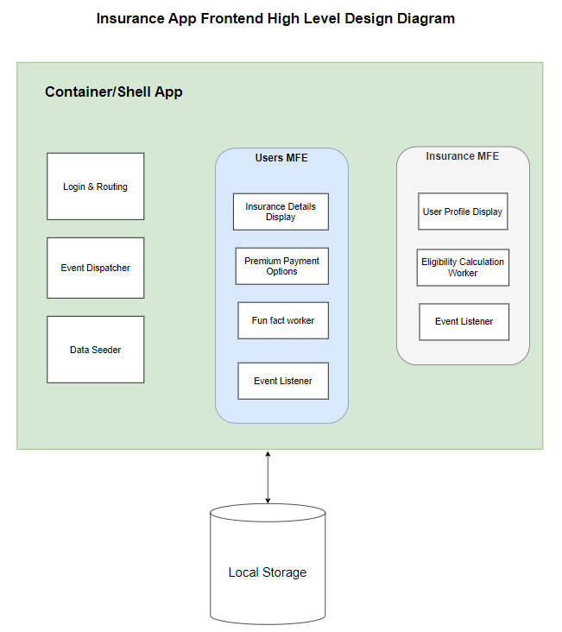

2. Key Components and Flow:
2.1 Container App:
- Responsibilities:
  - Authentication: Handles user login by validating the email format and checking if the user exists.
  - Event Dispatching: Sends events to micro-frontend apps (User and Insurance) to display messages.
  - Data Initialization: Seeds user and insurance data into local storage on startup.
  - Routing: Dynamically loads the respective micro-frontend apps (Users App, Insurance App) based on user actions.
  - UI Layout: Includes a sidebar navigation with links/buttons for Profile, Insurance, and Logout.
  - State Management: Passes user and insurance data to the micro-frontends while loading them from the container app.
- Key Functionalities:
  - Login: Validates the email and signs in the user.
  - Sidebar: Provides options to load the User and Insurance micro-frontends.
  - User Interaction: Redirects based on user’s choice and triggers events like "Send Message".
  - Logout: Clears data and redirects back to login screen.
2.2 Users App (Micro-Frontend):
- Responsibilities:
  - Profile Display: Displays user profile information fetched from local storage.
  - Eligibility Check: Uses a background worker to process user data (age, income, gender) and determine insurance eligibility.
  - Event Listener: Listens to messages/events from the Container App and displays relevant notifications or alerts to the user.
- Key Functionalities:
  - Data Fetching: Retrieves user details from local storage and displays it.
  - Offer Calculation: Background worker runs eligibility checks and calculates insurance offers.
  - Message Handling: Listens for any events (such as "Send Message") from the Container App and shows relevant messages.
2.3 Insurance App (Micro-Frontend):
- Responsibilities:
  - Insurance Details: Fetches and displays user’s insurance details from local storage.
  - Payment Gateway: Displays payment options and allows the user to pay the premium.
  - Fun Facts API: Simulates API calls to show random fun facts using a background worker.
  - Event Listener: Listens to events from the Container App for message display.
- Key Functionalities:
  - Display Insurance Data: Shows existing insurance details pulled from local storage.
  - Premium Payment: Allows the user to view and interact with payment options.
  - API Simulation: Background worker fetches fun facts periodically to simulate API interaction.
  - Message Handling: Listens for events from the Container App to show notifications.

3. Data Flow & Communication:
- Data Storage: Local storage is used for storing user and insurance data. The Container App seeds the data initially and passes it to the micro-frontends.
- Event Handling: The Container App can trigger events (e.g., "Send Message") that the User and Insurance micro-frontends listen for. When the event is received, the micro-frontends update their UI accordingly.
- Local Storage Usage:
  - Container App seeds user/insurance data.
  - Users App and Insurance App pull relevant data from local storage.
- Background Workers:
  - The Users App runs a worker to calculate the best insurance offers based on user data (age, income, etc.).
  - The Insurance App runs a worker to simulate periodic API calls that display fun facts.

4. Technical Stack:
- Frontend Framework: React
- CSS Preprocessor: SCSS
- Bundling: Webpack for packaging and bundling all micro-frontends.
- Communication: Local storage for sharing data and custom event listeners for inter-frontend communication.
- Background Workers: For asynchronous tasks like calculating insurance offers and fetching fun facts.

5. Deployment Flow:
- Local Development: Each micro-frontend (Container, Users, and Insurance) runs on separate ports (3000, 3001, 3002).
  - Container app runs on localhost:3000.
  - Users’ app runs on localhost:3001.
  - Insurance app runs on localhost:3002.
- Launch Flow:
  - First, the Container App is loaded (at port 3000).
  - On successful login, it loads the Users App (at port 3001) or the Insurance App (at port 3002), depending on user actions.
- Data Flow:
  - The Container App seeds and shares data with the micro-frontends via local storage.
  - Micro-frontends (Users and Insurance) retrieve this data and display the necessary information to the user.
  - Background workers handle tasks like eligibility checks and fun fact fetching.

6. Security Considerations:
- Cross-Site Scripting (XSS): The Container App ensures that email input is sanitized to prevent XSS attacks. Input validation is done on the login page to prevent malicious scripts.
- Data Integrity: Data stored in local storage is isolated per app and only accessible through the container or micro-frontends. In real app No sensitive data will be stored without proper protection.

7. User Interaction Flow:
- Login:
  - User enters email on the login screen of the Container App.
  - Container App validates the email format, checks if the user exists, and redirects to the landing page (either User or Insurance view).
- User Profile:
  - On clicking "View Profile", the Users App is loaded, displaying user details and insurance eligibility.
- Insurance Details:
  - On clicking "View Insurance Details", the Insurance App is loaded, displaying insurance details and premium payment options.
- Message Handling:
  - The Container App dispatches events (e.g., "Send Message") that are listened to by the Users App and Insurance App for dynamic updates.

Requirement Checklist:

Requirement | Status
Build container app | Done
Build One MFE for insurance details and premium payment | Done
Build Second MFE for user details | Done
Load both MFEs on container app | Done
Share data between containers and MFEs | - Data being shared using local storage.  - Container app is passing data to MFEs dynamically.  - Container app sending events to MFEs.
Store and Retrieve data from local storage | Done
Add worker to one of the MEFs to do anything | Done
Using webpack for bundling | Done
Use any CSS pre-processor | Used SCSS loader
Implement any one OWASP top 10 | Implemented XSS (prevented cross site scripting)

